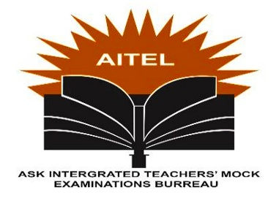

S.5 END OF TERM 1 2024 EXAMINATION

CHRISTIAN RELIGIOUS EDUCATION

(THE NEW TESTAMENT)

CRE 245/2

2 HOURS 30 MINUTES

INSTRUCTIONS

* Attempt only four (4) questions
* Ally questions carry equal marks
* Finishing is compulsory.

TOPIC: EARLY CHURCH

1. Discuss the contents of Kerygma as proclaimed in the early church. (25 marks)
2. To what extent did the holy spirit influence the spread of the gospel in the early church? (25 marks)
3. Comment on the characteristics of apostolic church. (25 marks)
4. Compare the methods of transmission of the gospel in the oral period with those in Uganda today. (25 marks)
5. (a) Analyze the obstacles faced in trying to spread the gospel in the early church. (12 marks)

(b) What problems do Christians face today while trying to spread the gospel? (13 marks)

1. Assess the impact of persecution on the spread of the gospel in the apostolic age. (25 marks)

END